**Project Release 1.0 Version**

**Wearable Guiding Aid Device for the Blind People**

by

Hanming Jing 1063855

Yihan Mao 1063956

Yihuai Zhang 1064213

Yingxu Wang 1064070

April 26, 2021

Department of Computer Science

Wenzhou-Kean University

**Abstract**

This 1.0 version of the wearable guiding aid device for the blind people project describes a series of project devices whose basic functions are implemented basically. In this paper, we first present the overall project in parts; then we explain the code of each part; and finally, we point out the parts of the project requirements that have not yet been implemented or that need to be improved.

**Permission to Use**

I agree that permission for copying this report, in whole or in part, for scholarly purposes may be granted by the adviser(s) of this work or by the Head of the Department. Any copying or publication or use of this report or parts thereof for financial gain shall not be allowed without my written permission.

**Acknowledgement**

We’d like to thank *Yudong Wang* for his proposal, *Xuan Ma* and *Zeyu Guo*’ssystem design document. We’d also like to thank *Xuanyu Pan* for his code guidance on Wi-Fi modules. Finally, we want to thank our instructor *Pinata Winoto*, for guidance during project realization.

**Introduction**

In our 1.0 version of the wearable guiding aid device for the blind people project, we develop our project based on the ideas in the proposal and the design in the SDD. In our project, two major components are developed, including the main object recognition program on the phone and the Arduino part for ranging and feedback. Besides these, there are still some parts to be optimized and developed, such as GPS positioning on the phone and a small vibration motor on the Arduino.

The relevant code on GitHub: https://github.com/Alfred-SMG/Group-2-1.0Ver.git

**Constructions and Codes**

**1. Unity3D Object Recognition Application (File Name: capstone1.0)**

This main application can recognize objects and make the phone vibrate when the object is captured.

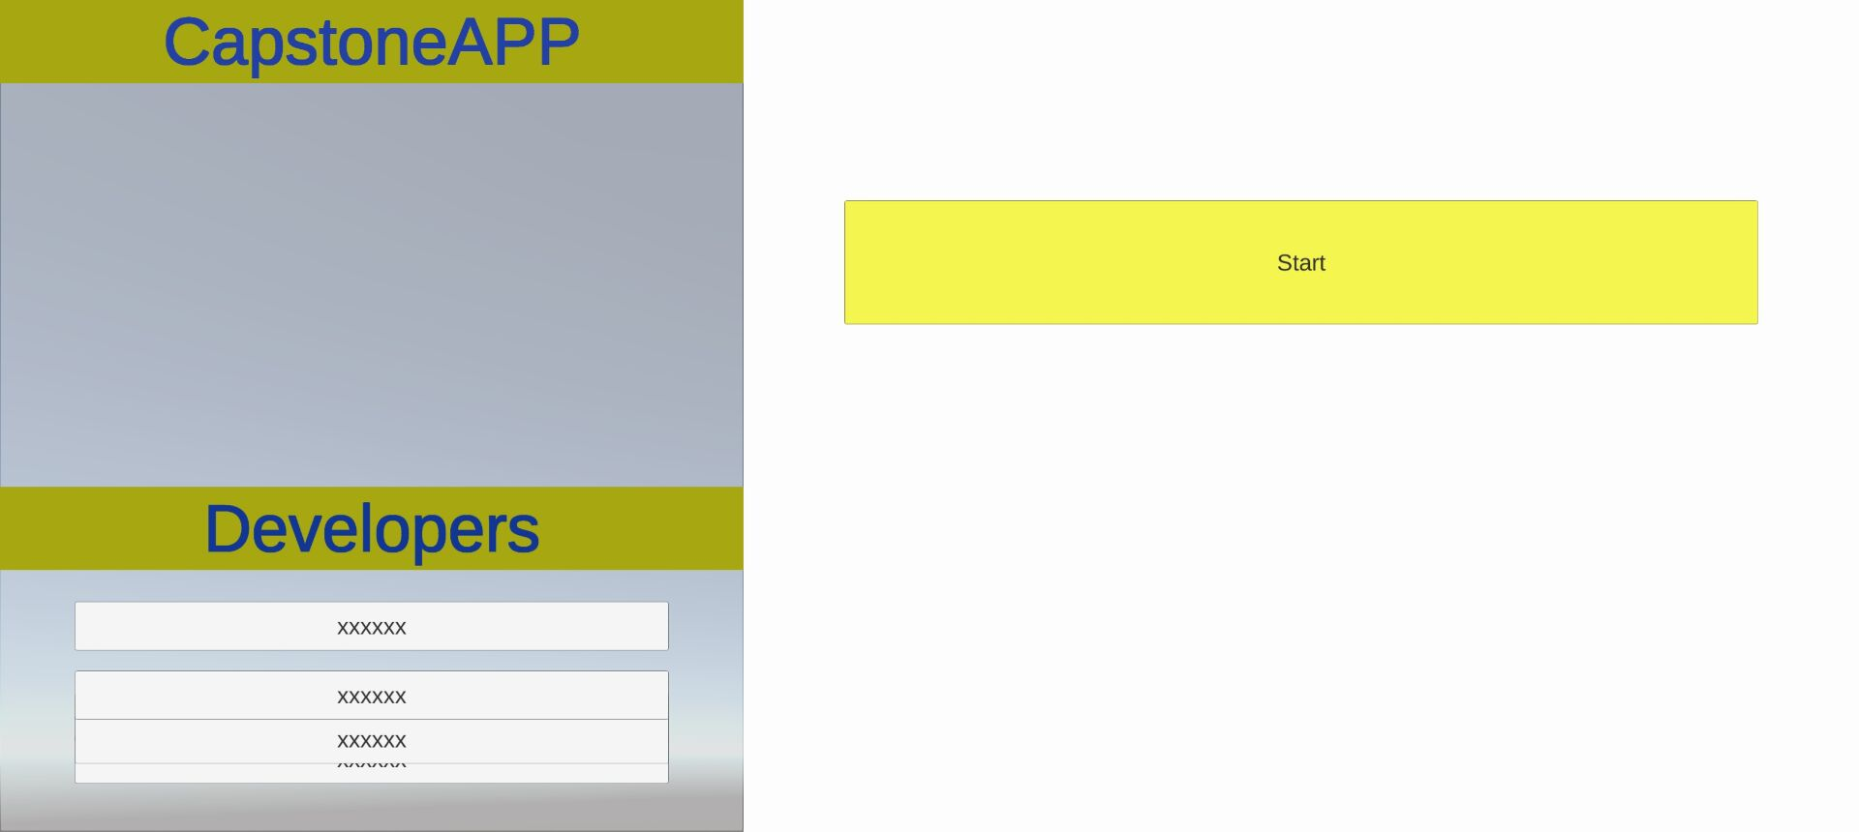

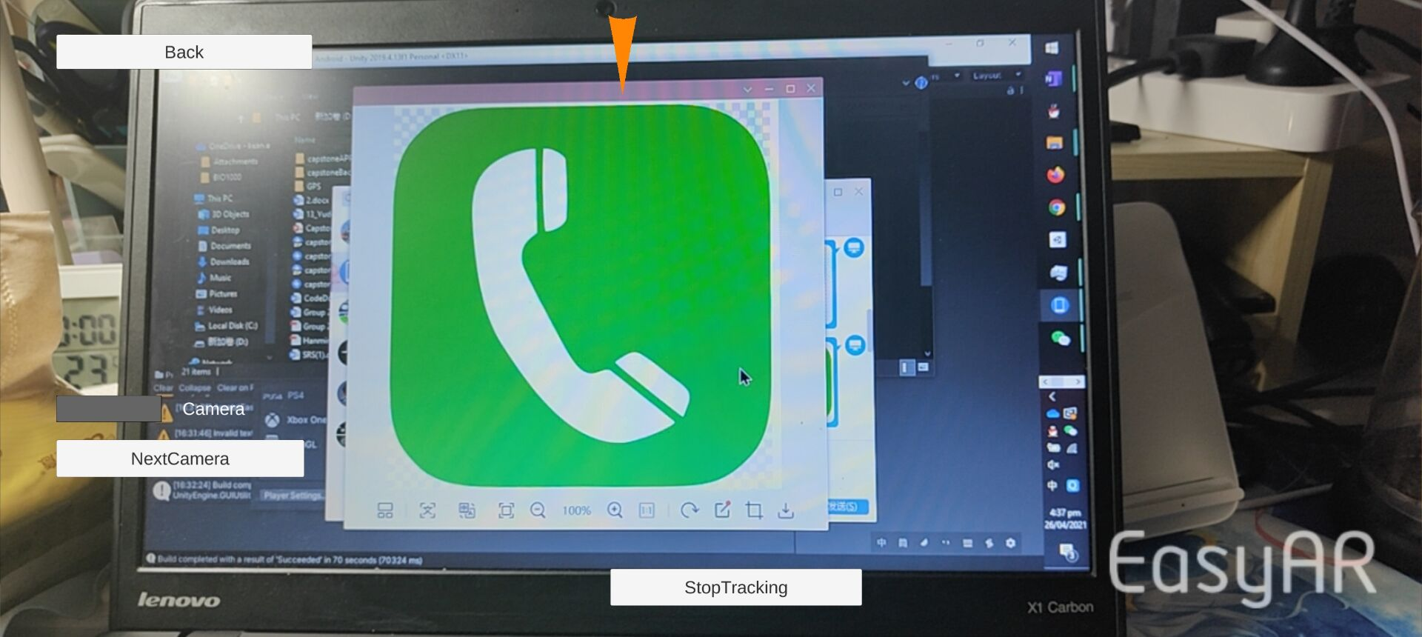

**2. Unity3D GPS Application (File Name: GPSlocate)**

This is an auxiliary program to help users better locate their location. The relevant code we have listed in the documentation. However, it has not been merged into the main program. Developers can choose to use it or not depending on the situation.

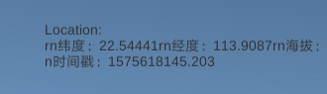

**3. Arduino UNO, ESP 8266 Wi-Fi module and related modules (File Name: Arduino_1, Capstone_Wi-Fi)**

Theoretically, this Arduino program and related modules are for wearable devices. It can be designed to be more ergonomic instead of on the breadboard.

We use an ultrasonic distance sensor in our project. The type of this ultrasonic distance sensor is HC-SR04. Using this ultrasonic distance sensor, we can measure the distance between the user and the obstacle using this ultrasonic distance sensor with Arduino. When turning on the application, we can see the port monitor are constantly outputting the distance between the sensor and the obstacle.

The Arduino UNO links the Wi-Fi module, Sonar module and Buzzer module. When the program is running, the Sonar module can detect the shortest distance obstacle directly in front. When the distance is less than 30cm, the buzzer will ring. Or user can send “warning” from the application, the buzzer will also turn on. User can send other messages such as “stop” to turn off the buzzer.

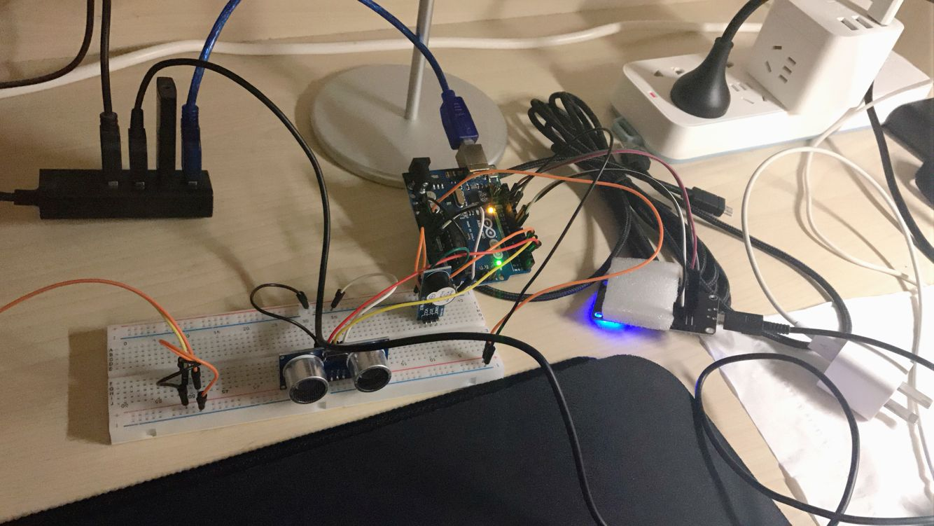

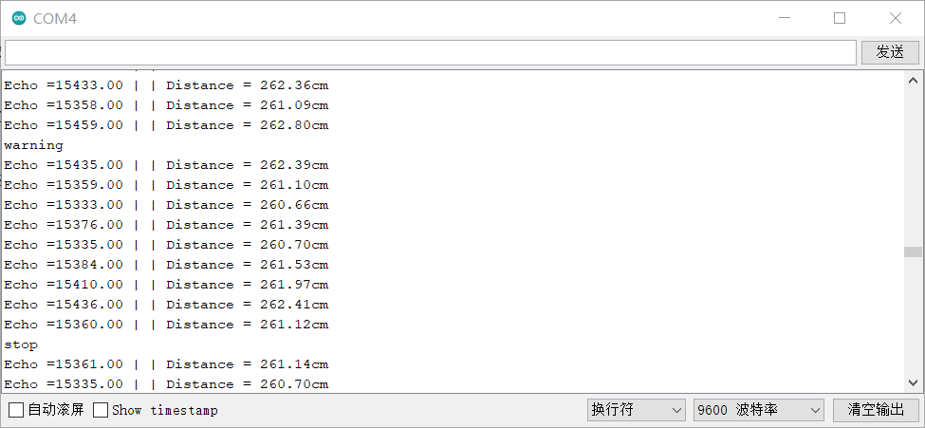

Note: ESP 8266 Wi-Fi module needs a separate power supply.

**4. Android Wi-Fi Link Application (File Name: Anyway)**

This application is for sending messages to the Wi-Fi module. Users can send “warning” to turn on the buzzer; or they can send other messages to stop the buzzer.

